**ZRO the public chain opens the battle of justice**

**At the crossroads where the storm of struggle for freedom is about to sweep, ZRO a retrograde sword, falling from the sky like the masked black man Zorro, the road to see the uneven bright sword stand up, police evil punishment, hoe strong weak, hope to return all mankind a just, equal, free living environment, bright sword of justice, return the world with justice, freedom, equality!**



Has been at the bottom of the dark net, by the world's top private equity funds known as the "next generation block chain technology new hope" ZRO platform has officially opened the public chain research and development work, in 2020 to start the war of justice.

ZRO platform was preceded by a group of geeks assembled by hackers who are at the top of the world's technology and often "zorro ".

Zorro is a well-known western literary image, known for his passion for chivalrous justice, robbing the rich and helping the poor, acting for heaven. And this group of hackers to Zorro self-comparison, is undoubtedly also with compassion, the lofty concept of universal beings.



ZRO platform is based on the openness and irreversibility of blockchain technology, combined with the current market situation of e-commerce, securities, online entertainment and other industries carefully built global-wide pan-business information management system and trading platform, Committed to building block chain bottom architecture technology logic and business model intelligent contracts, global product and service providers, logistics of life through the establishment of block chain bottom architecture technology logic and business model intelligent contract, global product and service providers, logistics enterprises and other intermediate trading links, consumers seamless connection, building block chain world commodity information exchange and trading system, and using the platform It is a blockchain project with global application scenario and grand ideal blueprint under the guidance of the latest top architecture concept of blockchain.

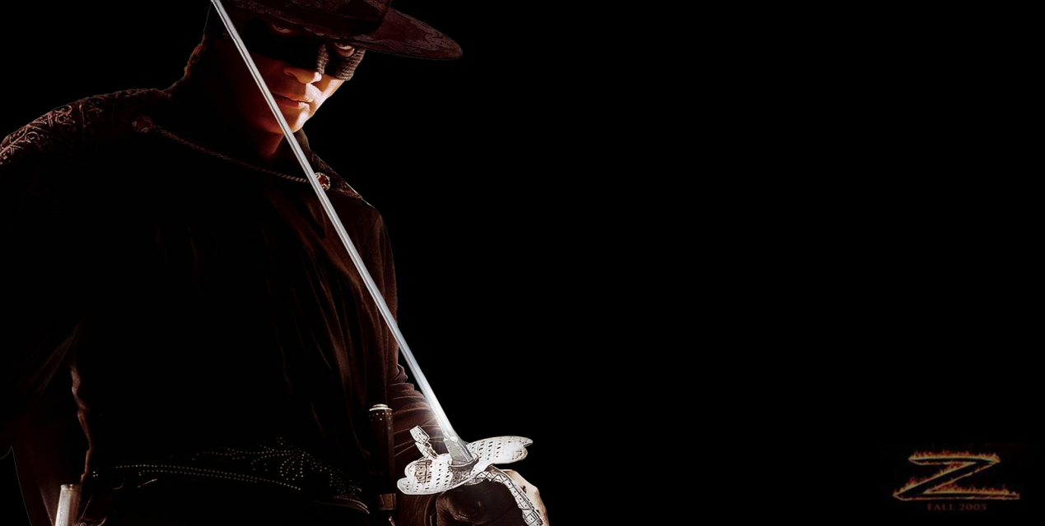

ZRO from the consumer level scene, using block chain technology to build a new task reward platform, social platform and other life service platforms, and then derived to e-commerce platform, copyright protection platform and other real economic fields, finally open up virtual economic paradigms including securities trading, card trading and other virtual economic paradigms to create a world-class integrated economic platform block chain.

Over the long term, ZRO will also actively promote the organic integration of blockchain technology with other cutting-edge technologies, such as big data technology and AI technology, optimize the network governance model, let the value of data return to themselves, balance the separation of individual consciousness and intelligence, and form a more efficient and credible cooperation; and then based on this, relying on the expanding business scale and user base, open up a wider market space outside the individual market, and create more application scenarios for platform tokens.



ZRO will create a whole ecology, a whole new dimension; not only carry a currency or an industry, but also bring real, comprehensive fairness, justice and openness to the world, so that every participant can enjoy the full range of freedoms of privacy, wealth and thought.